# Lab 11

Cube

Create an app that mimics the example cube-game.exe

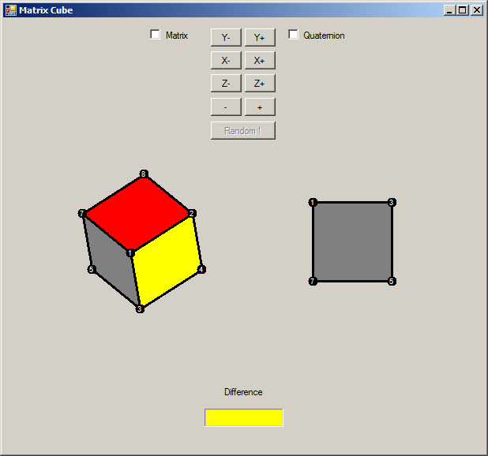

Cube Game

8 points in 3D space (using Vector3) are stored and rotated (using quaternions) about the origin along each of the three axis. The magnitude of rotation is controlled by a class variable (currently set to 5 degrees), and the distance from each vertex to the origin can be scaled by 25% (using a matrix). The pseudo 3D look is achieved by a parallel projection where the z co-ordinate is discarded. (similar to a house elevation of vehicle schematic)

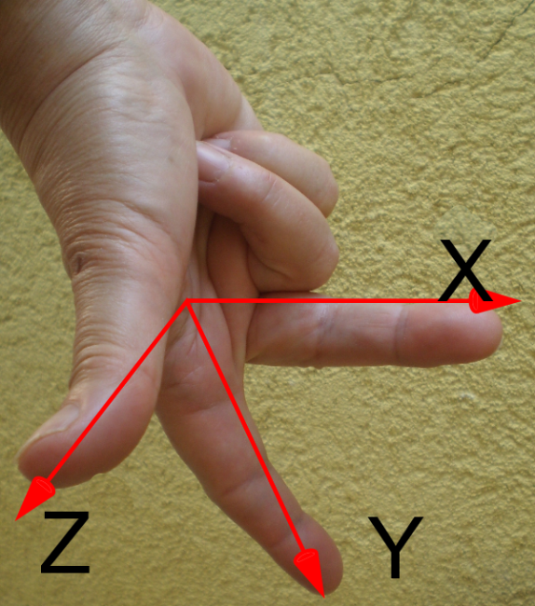 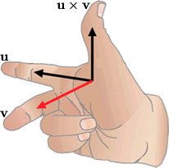

Right Hand rule if you align the digits on your right hand as in the picture middle finger on X axis, first finger along Y axis then your thumb will point along the Z Axis. All in the positive direction. We will use the fact that the cross product of two vectors is orthogonal to both. So if we choose two vectors from each face pointing away from a corner of the cube their cross product will point away from the cube centre (core, origin) and it’s Z component will tell us if the face is point towards us (Z is positive) or away (Z is negative). We will only draw the faces pointing towards us.

The geometric centre of both cubes is the origin, when drawing the cubes a constant (Vector3) is added to the vertex to move the cube from the top left to a more central location, these should be different for the two cubes. When drawing the parallelograms for the faces disregard the Z co-ordinate.

Code snippets.

Class wide variables  
 int sizex ˭ 50ˏ sizey ˭ 50ˏ sizez ˭ 50;

int angle ˭ 5;

Vector3[] box ˭ new Vector3[8];

bool[] showVertex ˭ new bool[8];

Initialise the cube vertexes  
box[0] ˭ new Vector3(-sizexˏ -sizey ˏ sizez);

Draw a face if the cross product of the two edges points towards us. DrawVector is the 3D location of the vertex translated to a central location.

//Draw the 1-2-3-4 face, if needed. ^ is operator overload for cross product vertex's 1 and 4 are diagonally opposite as are 2 & 3

if(((drawVector1-drawVector2) ^ (drawVector4-drawVector2)).z < 0)

Use  ***Graphics.FillPolygon(brush,Points[])*** to draw the faces.

And

***Font drawFont = new Font("Arial", 8);***

***Graphics.DrawString(string,Font, Brush,Point***) to label the vertices.

Do the project in two parts (4 steps)

1. Draw one stationary cube.
2. Rotate one cube using quaternions. (see cube2.exe)
3. Rotate second cube using matrices.
4. Add random and measure. (see cube4.exe)

Initial co-ordinates for first part only. (after that initialise cube parallel to axis)

You can cut & paste this block of code but cannot use the variable name “box” as an array of vector3

box[0] = new Vector3(-69.9,-49,14.6) ;

box[1] = new Vector3(11.6,-78.2,-35.4);

box[2] = new Vector3(-12,-8.4,85.4);

box[3] = new Vector3(69.5,-37.6,35.4);

box[4] = new Vector3(-11.6,78.2,35.4);

box[5] = new Vector3(69.9,49,-14.6);

box[6] = new Vector3(-69.5,37.6,-35.4);

box[7] = new Vector3(12,8.4,-85.4);

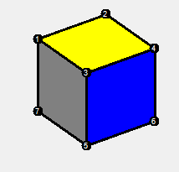

The design doc should be less than 2 pages with the narrative description taking less than ¼ page There is no need to mention formulas used in previous projects (ie. It is sufficient to say get a rotation matrix for the angle 5 degrees) {No need to mention radians, cos or sin}

Design Doc due 15/3/16 in games class

Part 1 Due 7/4/16 (50%)

Rest of project Due 21/4/16 (50%)

You must attempt to draw all six faces and discard (cull) faces that don’t point towards the camera anyone only drawing (or drawing last) the 3 faces pointing toward the camera will get zero marks.

You should use your own vector3, matrix and quaternion classes, not someone else’s. You should use the appropriate methods and never access the properties of the class (don’t do maths in the form class). So create a ConvertThisVectorInToAPoint method for your vector3 to return a point using the X&Y properties. Also create an IsThisVectorPointingTowardsTheCamera method based on the sign of the z component.

*As the habit of using someone else’s code has become acceptable for some of you*

*Just to be explicit, if the same code appears in two students projects both of you will receive zero marks for your CA. You should not under any circumstances open a file written by another student. All the code in your project should be typed letter by letter by you. It is cheating to work together on a single piece of code and both use a single digital copy of that code. You however can talk to each other show (eyes only) each other your code and explain with or without pictures how your code works. Code you find on the InterWeb or books should be read and then inspire you to write your own code, never cut & paste.*